**Honors Pre-Calculus Unit 5 - Chapter 2 Assessment: Polynomial and Rational Functions**

**Name: _____________________________­­­­­_____ Date: ___________Block: __________________**

*Show your work when appropriate. Use complete sentences for all written responses.*

**Level 2**

*The monthly revenue (in thousands of dollars) from the sales of a digital picture frame is approximated by: , where is the price per unit (in dollars).*

1. Find the unit price that will yield a maximum monthly revenue.
2. What is the maximum monthly revenue?

*Simplify the following expressions.*

1. ________________________

*Use the graph to the right to answer the following questions.*

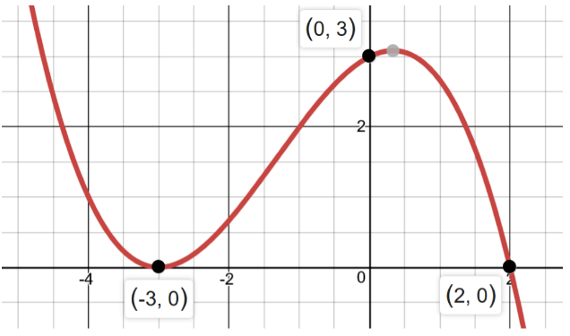

1. State the real zeros.
2. Describe the end behavior using appropriate notation.
3. Describe the interval where .

*Given answer the following:*

1. Find all zeros: ___________________________
2. State the degree: ________________________
3. Identify the max: ________________________ and min: ________________________
4. Describe the end behavior: ________________________

**Level 3**

1. Find a polynomial function with real coefficients that has the given zeros.

1. *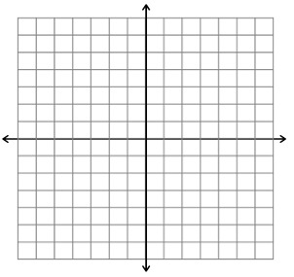Sketch the graph of the function. Identify the multiplicity of each zero.*

Linear factorization: ___________________________   
  
Zeros: ____________________

1. a*.) Sketch a rational function that has horizontal asymptote at , a y-intercept at (0, 4), vertical asymptote at x = – 1, a hole when and zero at .*



b.) *Write a possible equation for the graph.*

*Identify any intercepts, holes and asymptote of the graph of the function. Write “none” in the blank if the graph does not have a particular aspect. Then sketch a graph of the function.*

1. 15.

vert. asymptote. vert. asymptote.

horiz. asymptote. horiz. asymptote.

x-intercept(s) x-intercept(s)

y-intercept y-intercept

hole(s) hole(s)





**Level 4**

1. The path of a ball thrown by a child is modeled by: where y is the height of the ball and x is the distance from the point from which the ball is thrown. Using your knowledge of slopes of tangent lines, show that the height of the ball is increasing on the interval [0,2] and decreasing on the interval [3,5]. Explain your reasoning.
2. For what value of *k*, is the divisor a factor?

Key

1. $79
2. $62,410
3. 3
4. Negative
5. , zeros:
6. Various answers, example:

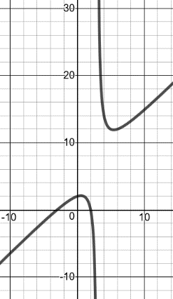

1. VA:

HA: none

SA:

*x*-int:

*y*-int:

hole(s): none

1. 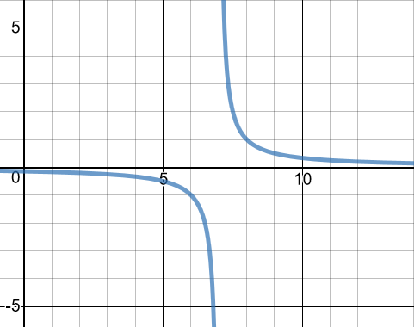VA:

HA:

SA: none

*x*-int: none

*y*-int:

hole(s):

1. Zeros: